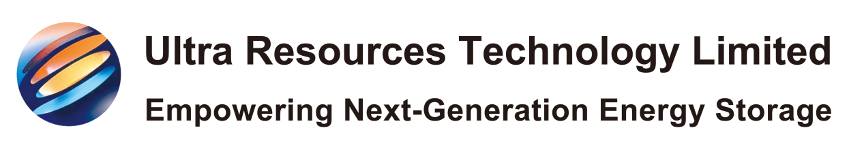
Sample Request Form

SECTION 1: REQUESTER INFORMATION
(All fields mandatory)
Name: ____________________
Job Title: ____________________
Company: ____________________
Address: ____________________
City/Postcode: ____________________
Country: ____________________
Email: ____________________
Phone: ____________________
How did you hear about us? ☐ Conferences ☐ Website ☐ Referral ☐ Other: ______

SECTION 2: REQUESTED SAMPLES
(Select materials – Max 1 set per company)

Material | Quantity | Options (Check if applicable)
☐ Cathode Materials | 20g | ☐ Pre-lithiated  ☐ Non-pre-lithiated
☐ 3D Mg-Li Alloy Current Collector | 1 piece | Size: ______ mm
☐ SPAN Composite Cathode | 20g

SECTION 3: TESTING PURPOSE

Application Area:

☐ Electric Vehicles ☐ Consumer Electronics ☐ Energy Storage ☐ Research ☐ Other: ______

Planned Tests:
Describe testing methodology/standards (e.g., coin cell testing, cycling performance, etc.)
________________________________________________________
________________________________________________________

SECTION 4: TERMS & CONDITIONS
☐ I confirm this sample will be used only for R&D purposes.
☐ I agree to provide test results to Ultra Resource within 90 days.
☐ I understand samples are free of charge but shipping costs/ taxes may apply.
☐ I acknowledge that material properties are confidential and covered under NDA [Attach if required].

SUBMISSION
Requester Signature: _________________________
Date: __________

